EXPT NO:6 | IMPLEMENTATION OF MULTIVARIATE DISPLAYS
DATE: 24.01.2026 | IMPLEMENTATION OF MULTIVARIATE DISPLAYS

PRE-LAB QUESTIONS
- Why are multivariate displays important in AI analytics?
Multivariate displays are important in AI analytics because AI models rely on multiple features simultaneously, and these displays help reveal relationships, correlations, patterns, and interactions among variables that cannot be identified using univariate or bivariate analysis.
- How do parallel coordinates differ from scatter plots?
Parallel coordinates visualize multiple variables at once by mapping each variable to a separate axis, whereas scatter plots are limited to showing relationships between only two or three variables, making parallel coordinates more suitable for high-dimensional data.
- What challenges exist in interpreting multivariate plots?
Challenges include visual clutter, overlapping data points, difficulty in interpreting multiple axes, color confusion, and the need for domain knowledge to correctly understand complex relationships.
- Where are trellis displays commonly used?
Trellis displays are commonly used in retail analytics, healthcare analysis, financial data analysis, and machine learning model evaluation where comparisons across different groups or categories are required.
- How does multivariate visualization aid model evaluation?
Multivariate visualization aids model evaluation by revealing feature interactions, identifying biases across groups, detecting outliers, and helping assess model behavior beyond aggregate performance metrics.

OBJECTIVE : To implement advanced multivariate displays for complex data analysis.

SCENARIO: A retail analytics firm studies sales, profit, customer segment, and region to optimize business strategy.

IN-LAB TASKS (Using R Language) • Create parallel coordinate plots • Generate bubble charts • Implement trellis displays by region

CODE:

install.packages(c("GGally", "ggplot2", "lattice"))
library(GGally)
library(ggplot2)
library(lattice)
retail <- read.csv("6.retail_business.csv")
str(retail)
ggparcoord(
data = retail,
columns = c("Sales", "Profit"),
groupColumn = "Customer_Segment",
scale = "standardize",
alphaLines = 0.4
) +
ggtitle("Parallel Coordinates: Sales vs Profit by Segment") +
theme_minimal()
ggplot(retail, aes(x = Sales, y = Profit,
size = Sales, color = Region)) +
geom_point(alpha = 0.6) +
scale_size_continuous(range = c(3, 12)) +
ggtitle("Bubble Chart: Sales vs Profit by Region") +
theme_minimal()
ggplot(retail, aes(x = Sales, y = Profit, color = Customer_Segment)) +
geom_point(alpha = 0.6) +
facet_wrap(~ Region) +
ggtitle("Trellis Display: Sales vs Profit by Region") +
theme_minimal()
my_roll_no <- "23BAD109"
print(paste("Lab completed by roll number:", my_roll_no))

OUTPUT:

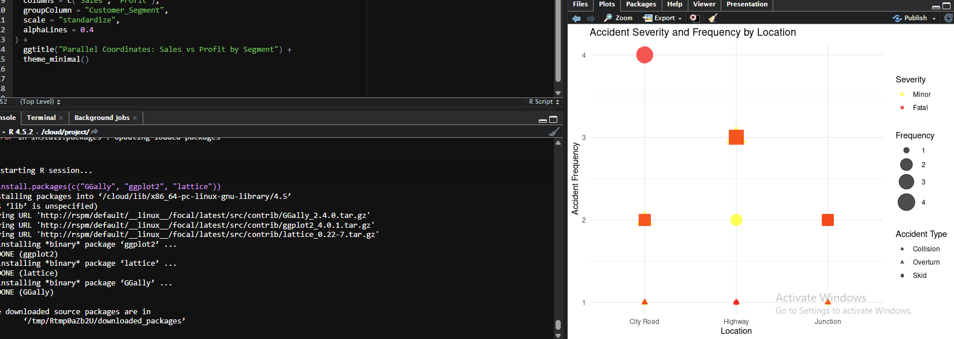

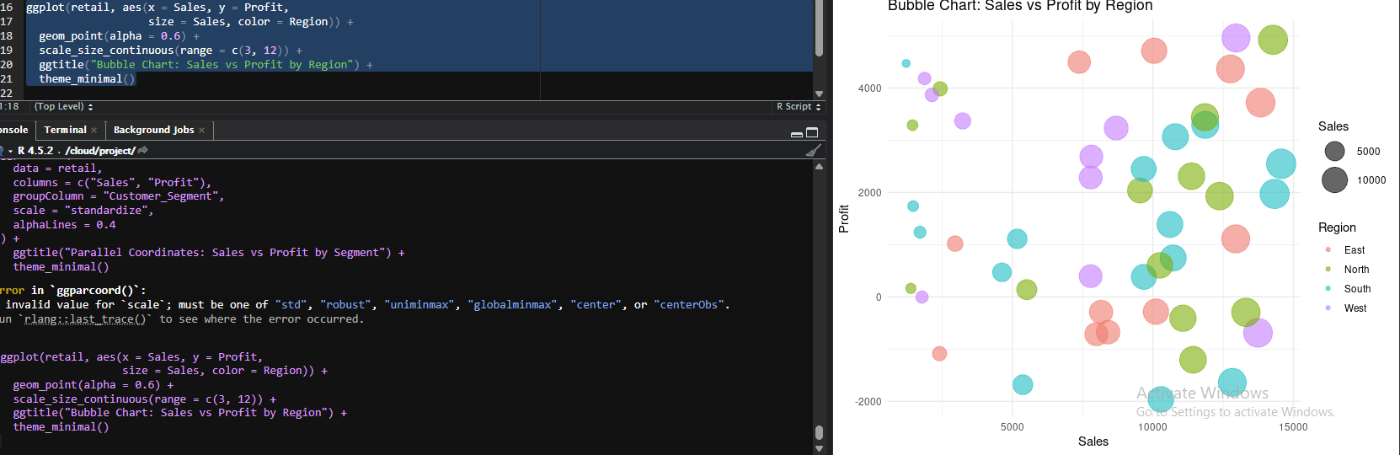

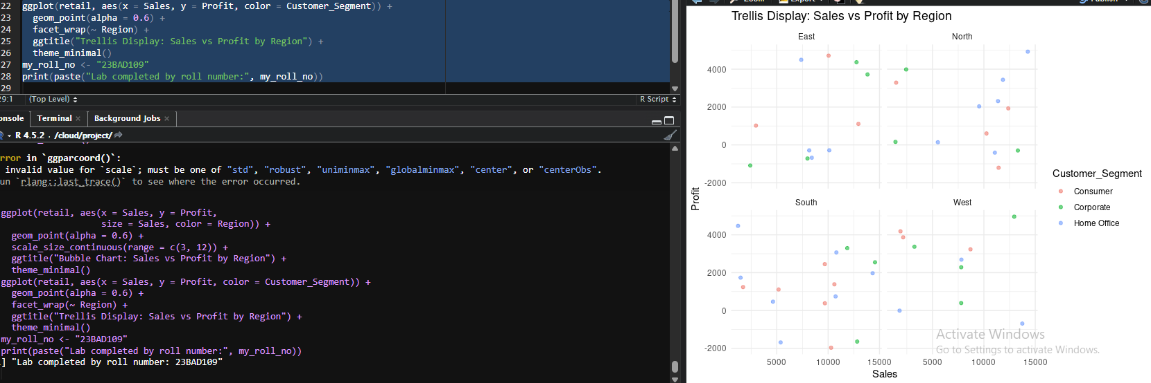

POST-LAB QUESTIONS
- What insights are gained from parallel coordinates?
Parallel coordinates provide insights into how multiple variables change together, helping identify patterns, inconsistencies, and dominant trends across different data segments.
- How does faceting simplify complex data?
Faceting simplifies complex data by dividing it into smaller, category-based panels, allowing easier comparison and reducing visual clutter while preserving important relationships.
- What limitations exist in bubble charts?
Bubble charts suffer from poor perception of area, overlapping bubbles, difficulty in precise comparison, and limited effectiveness when visualizing many variables or large datasets.
- How can these displays support AI-driven recommendations?
These displays support AI-driven recommendations by visually identifying profitable segments, regional trends, and feature interactions that inform better decision-making and model-driven strategies.
- Suggest improvements for large multivariate datasets.
Improvements include applying dimensionality reduction techniques, using interactive visualizations, filtering or sampling data, and integrating model-based feature importance to enhance interpretability.

ASSESSMENT
Description | Max Marks | Marks Awarded
Pre Lab Exercise | 5
In Lab Exercise | 10
Post Lab Exercise | 5
Viva | 10
Total | 30
Faculty Signature

